Cinema Management System

Software Requirements Specification

Version 1.0

Revision History

|  |  |  |  |
| --- | --- | --- | --- |
| **Date** | **Version** | **Miêu tả** | **Author** |
| 18/09/2020 | 0.1 | Initial document | Ngô Thị Ngọc Thơ |
| 18/09/2020 | 1.0 | Updated document | Ngô Thị Ngọc Thảo |
| 19/09/2020 | 1.2 | Reviewed and updated document | Võ Phước Sang |
| 03/01/2021 | 1.3 | Reviewed and updated document | Phạm Nguyễn Hữu Phương |

Table of Contents

1. Introduction 4

1.1 Purpose 4

1.2 Scope 4

1.3 Definitions, Acronyms and Abbreviations 4

1.4 References 4

2. Overview 4

3. Functional Requirements 5

3.1 Account Management 5

3.2 Movie Management 7

3.3 Showtime Management 8

3.4 Booking 8

3.5 Payment 9

4. Non-functional Requirements 10

4.1 Usability 10

4.2 Security 10

4.3 Availability 10

4.4 Reliability 10

4.5 Performance 10

4.6 Scalability 10

4.7 Internationalization (I18N) 10

4.8 Modifiability 11

4.9 Documentation 11

Software Requirements Specification

# Introduction

## Purpose

The subject "Cinema management system" is intended to fully describe the features of the Cinema management system. It provides project development participants as well as the customer understanding what the system is capable of and how the process is done.

In fact in the software development process, at each stage a different document is built corresponding to that stage. To minimize the complexity of documents in the teaching process, this material is consistently developed throughout the project development process.

## Scope

This document covers all stages of the CMS application development process up until the beginning of the programming process.

## Definitions, Acronyms and Abbreviations

|  |  |
| --- | --- |
| **Term** | **Description** |
| **SRS** | Software Requirements Specification |
| **CMS** | Cinema Management System |

## References

[1] CMS Software Architect Document

[2] Documents of lecturer Nguyen Trong Minh Hong Phuoc - Saigon International University.

# Overview

In the current movie theaters, the management and organization of movie showings, ticket sales is always a matter of concern. The manager always had difficulty managing the ticketing process. Customers have to wait in line for hours to buy movie tickets. For that reason, the number of customers going to the cinema is also less, the theater's collection is also affected. Therefore, creating a cinema management software is an indispensable need. The cinema management system is built based on the actual requirements of customers and managers to solve problems encountered, reduce many risks in the process of managing the cinema. The system is aimed at customers and employees in the theater. The system has main functions including: movie management, theater management, ticket management, ticket booking, user management and customer information management. These functions help the manager to easily control the theater operation and customers can buy tickets very conveniently.

This document describes two main sections, ie the functional requirements and the non-functional requirements for the Cinema Rap application.

# Functional Requirements

## Account Management

This requires the employee, the owner, to log into the system before they can view the features of the CMS application. It prevents unauthorized users from accessing sensitive data. In addition, the CMS application must be secure, authenticated using at least a username and password. Passwords must be strong, conform to security standards, at least 8 characters, a combination of upper and lower case letters and numbers, and include at least one special character.

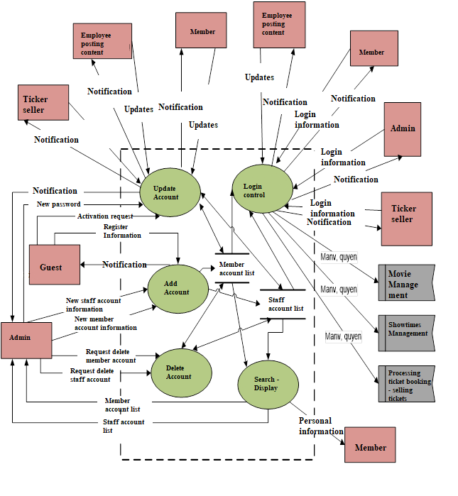

## Movie Management

People in the role of movie manager or admin will have the right to add, edit, and delete movies.

Movie listings can be viewed by employees, clients, loyal customers, movies will be displayed on computer screens or mobile devices.

When employees want to add, edit, or delete movies, they must ask the administrator to do it.

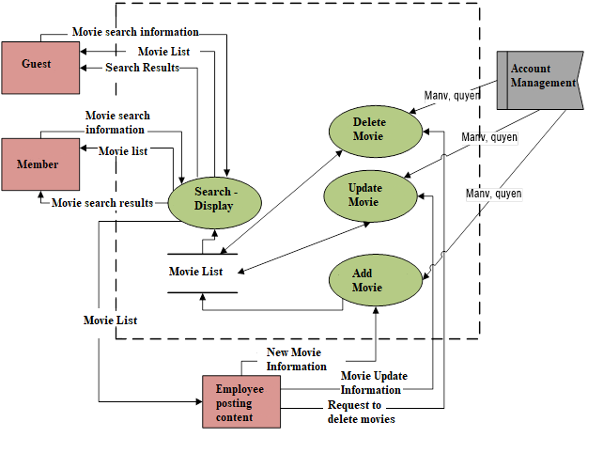

## Showtime Management

The show schedule manager will be able to add, edit, and delete showtimes for that movie.

The unauthorized person will have to ask the schedule manager or admin if he wants to add, edit, or delete showtimes.

Showtimes can be viewed by any audience.

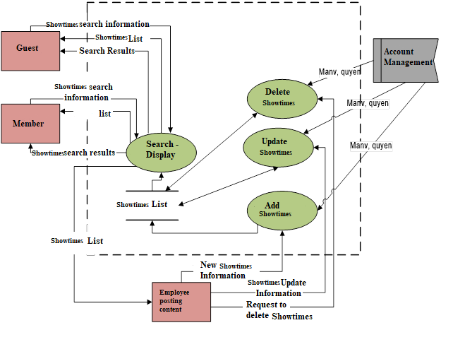

## Booking

When customers come to buy tickets, staff should in turn contact the customer according to the following steps:

Step 1: Ask the customer about the membership card, if they do not have it, the staff must introduce the customer as well as instructions on how to use the membership card, then invite the customer to register for a membership card.

Step 2: Ask customers the title of the movie they want to see, then select the form "Book" to select the required movie title. After the customer has selected the movie title and show date, the system will display the showtimes for that movie in the day.

Step 3: Ask customers about showtimes, after choosing the system will display the showrooms of the movie in the selected time period.

Step 4: After selecting a projection room with empty seats, the system will display the seat map corresponding to the customer's seat position in the cinema room. There are 3 types of seats: VIP seats, regular seats and double seats. Each seat type corresponds to a different fare.

Step 5: Let customers choose a chair. (Employees actively suggest choosing chairs and other services such as corn, water, souvenirs, ... to increase revenue.)

Step 6: Staff confirm the information you have selected with the customer again before printing the ticket.

Step 7: Click "Print ticket" to print tickets and deliver tickets to guests with their thanks.

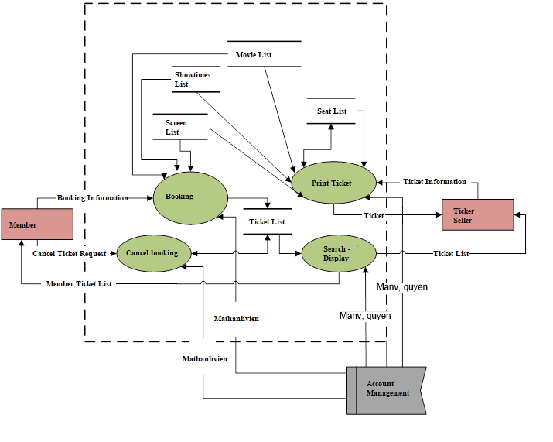

## Payment

Customers can pay right after receiving movie tickets. After the ticket office staff helps customers to book tickets and reconfirm movie information before printing tickets, the customer proceeds to pay for tickets plus other services such as meals, souvenirs, ... Month is stored, receipts are printed and sent to customers with detailed information, including time, theater name, cinema address, movie information, theater, seating location, services, fares , ...

Regarding payment methods, the CMS application can support cash, credit cards, gift cards, membership cards, ... Besides, administrators can add, modify or delete payment methods. new depending on the scalability of the CMS application.

# Non-functional Requirements

This describes some of the basic non-functional requirements of an CMS application. For details, please refer to the CMS.docx Software Architecture Documentation.

## Usability

CMS applications are subject to the latest in user experience standards and assistive technologies, so that people can use the system easily and save time and operating costs.

## Security

The CMS application must be secured in order for the customer to make payments online. It should support at least authentication using username and password, compliance with security standards, authorization, data integrity, secrecy, etc.

## Availability

The CMS application must ensure a high availability architecture with failover.

## Reliability

The system must be robust and operate to the functional specification. The system cannot fail to execute functions.

## Performance

The performance requirements of the CMS application are as follows:

• Download time and login time will take less than 5 seconds

• Queries will return results within 5 seconds

## Scalability

Scalability is the ability of a system to gracefully handle an increasing number of jobs, or the ability to expand with more resources to accommodate that growth.

## Internationalization (I18N)

The system must be able to handle multiple languages (at least English and Vietnamese).

## Modifiability

CMS applications must adhere to a modifiable-enabled architectural style. N-tier architectural style allows for the ability to modify the original system.

## Documentation

The CMS application must include a user manual, administrative manual, or online help.